INTERNSHIP PROJECT REPORT ON

MULTI-PAGE RESPONSIVE WEB DESIGN

“About Nike”

Shravanth Vidyacharan

B.E in Information Science and Engineering NMAM Institute of TECHNOLOGY, Nitte Karkala, Udupi 574110

Page 1

Abstract

Today’s extra small devices i.e. mobile phones, smartphones, tablets, mini laptops; medium devices like laptops, desk-tops; and large devices like new age TVs, LEDs, and projector screens capable of accessing websites have changed the approach towards web- site design and development. These high-tech devices and gadgets have placed the web designers and developers to serious issues of user experience and accessibility. Web Design by which developers can now produce device agnostic websites which respond, with respect to their layout and content presentation, on all kinds of device resolutions without requiring any special modifications. This means a single Responsive Website is now sufficient to serve all device sizes. But being device agnostic is only the first milestone towards responsiveness. This monograph discusses the factors that reasoned the Responsive Web Design.

Purpose – Web design has been identified as a key factor for the acceptance and success of the websites and electronic commerce. The purpose of this paper is to analyse, from a marketing point of view the main aspects that could influence online users' perceptions and behaviours, in order to achieve a successful e-commerce website. Design/methodology/approach – An extensive literature review was developed emphasising the special role that web design could play in the interaction user-interface. Besides, the methodology related to benchmarking allows firms to know the best practices and to learn some key lessons for developing their businesses online. Findings – The literature review affirms that web design is a key factor for getting positive outcomes as it influences on users and online consumers' perceptions and behaviours. A website design addressed to simplicity and freedom of navigation provides clear, timely and accurate information in all its contents and an appearance that calls for the users' attention. Research limitations/implications – The paper offers a Decalogue of guidelines that could improve the design of the e-commerce websites regarding the aesthetic appearance of the website, the navigation through the site, the information and contents and the characteristics of the shopping process. It could be interesting to analyse empirically the impact of all key attributes on the users' perceptions and behaviours. Originality/value – This is one of the first studies which explains how a website must be designed from the demand's perspective. The analysis of the users' perceptions and the marketing view of design could help designers to find the website that best matches their users' needs and so, to improve the relationships between users and companies through their interfaces.

Page 2

Table of content

* Abstract 1
* Table of Contents 2
* List of Figures 3
* Introduction 4
* Software Requirement Specification 5
* Implementation 6
* Results 8
* Conclusion 16

Page 3

List Of Figures

* Desktop view of index page
* Mobile view of index page
* Desktop view of About page
* Mobile view of About page
* Desktop view of News page
* Mobile view of News page
* Desktop view of contact page
* Mobile view of contact page

Page 4

Introduction

Web design is the planning and creation of websites. This includes a number of separate skills that all fall under the umbrella of web design.

Some examples of these skills are information architecture, user interface, site structure, navigation, layout, colors, fonts, and overall imagery. All of these skills are combined with the principles of design to create a website that meets the goals of the company or individual from whom that site is being created.

When you work as a web designer, you may be tasked with creating (or working on) entire sites or just individual pages and there is a lot to learn to be a well-rounded designer, including the following:

* HTML — This is the structure of web pages, creating the foundation of all websites
* CSS — This is how web pages are visually styled. CSS (Cascading Style Sheets) handles the entire look of sites, including layout, typography, colors, and more
* JavaScript — This governs certain behaviors on websites and can be used for a variety of interactions and features
* CGI programming — CGI, and the next few entries (PHP, ASP, etc.) are all different flavors of programming languages. Many sites do not require any of these languages, but sites that are more feature-rich will certainly need to be coded using some of these languages
* PHP, ASP, ColdFusion scripting
* XML
* Server management — All websites need to be hosted. The management of the servers that host those sites is an important web design skill
* Design — Creating the visual look and feel of websites has always been an important aspect of the industry
* Speed — A successful site is one that loads quickly on a wide variety of devices, regardless of a visitor's connection speed. Being able to tune the performance of sites is a very valuable skill
* Content — People come to websites for the content that those sites contain. Being able to create that content is a critically important component in the world of website design

Page 5

Software Requirement Specification

* **User Management Requirements**

his category of requirements is related to user authentication mechanism and workspace management of users. Each user will have credentials to connect their workspace on cloud and will be assigned to workspace. Users will perform all the functionality over this workspace using his credentials.

* **Code Editor Requirements**

One of the most important functionalities expected from an integrated development environment is a code editor which will ease the developer’s life. Code editor will be the main interface that developers deal with. It supports variety of programming language with highlighting, syntax checking, auto-indentation and language specific auto-complete.

* **Debugger Requirements**

Debugger is the main tool that developers can test and debug their target program. Debugger of the product should allow setting and displaying breakpoints on the code. It will also provide functionality of stopping/continuing of the execution of debugger. Finally, it will provide an expression interface where user can enter an expression and observe the value of expression at each step.

* **Terminal Requirements**

As an important part of the software development process, an integrated development environment should provide a command line interface where user can work in old fashion and accomplish complicated tasks such as configuring git synchronization. Main component of CLI will be the terminal. Terminal will allow user to run UNIX command on his own workspace and also run predefined programs such as mvn, svn etc. Terminal will also provide auto-complete by list of available commands and browse in the command history.

* **Interface Requirements**

This group of requirements is related to external interaction of the workspace with outer world. For user to interact with the workspace, product will provide both command line interface and graphical interface.

Page 6

Implementation

* **What Is the Purpose of the Site?**

Knowing the purpose of the site will help you set goals for the site as well as help to determine your target audience.

Goals are useful for most websites as it helps you measure how the site is performing, and whether it is worth expanding and improving the site.

And knowing the target audience for a site can help you with design elements as well as appropriate content. A site targeting seniors is going to have a completely different feel from one targeting teenagers.

* **Start Planning the Site Design**

Many people think this is where you jump into your web editor and start building, but the best sites start with a plan and start that plan even before the first wireframe is built.

Your design plan should include:

* Details about the information architecture.
* The planned structure of the site.
* A site map of the pages to be designed and built.
* And technical details like if scripts or Ajax will be used, whether there will be a server-side language like PHP in use, if you need a shopping cart and so on.
* **Design Starts After Planning**

This is where most of us start to have fun — with the design phase of the project. While you can jump right into your editor now, we recommend you still remain outside of it and do your design in a graphics program or even on paper first.

You will want to think about:

* Wireframes and the layout of your designs.
* Color including creating a color scheme for the site and how those colors work together in harmony.
* You should also plan on a theme for your site including decorative images and icons, including a site favicon.

Page 7

* **Gather or Create the Site Content**

Content is what people come to your site for. This can include text, images, and multimedia. By getting at least some of the content ready ahead of time, you can more easily start building the site.

You should look for:

* Text: this can be articles, blog posts, lists, reviews, or anything that you want to write about on your site.
* Graphics: there are lots of places to find images for web pages including photos you’ve taken and free images. Be sure you’re using the right format for your images.
* Multimedia: Remember that multimedia can have a negative impact on your site. Make sure that you're adding sound and video to your sites appropriately.
* **Now You Can Start Building the Site**

If you’ve done a good job planning and designing your site, then building the HTML and CSS will be easier. For many of us, this is the best part.

You will use lots of different technologies to build your site:

* HTML: this is the basis of your website, and if you learn nothing else, you should learn HTML.
* CSS: Once you know HTML, CSS helps you create the design you planned. And CSS is easy to learn.
* CGI
* JavaScript
* PHP
* Databases
* **Then You Should Always Test the Site**

Testing your website is critical both throughout the building phase and after you’ve got it built. While you’re building it, you should preview your pages periodically to make sure your HTML and CSS are working correctly.

Then you want to make sure:

* The site meets the goals set out in step one. Does this site fulfill its purpose?
* The technical features (HTML, CSS, scripts, and so on) work correctly. Troubleshoot any problems efficiently, and remember to validate.
* The design works in significant browsers.

Page 8

RESULTS

Following are the screenshots of index pages

* **Desktop view of index page:**

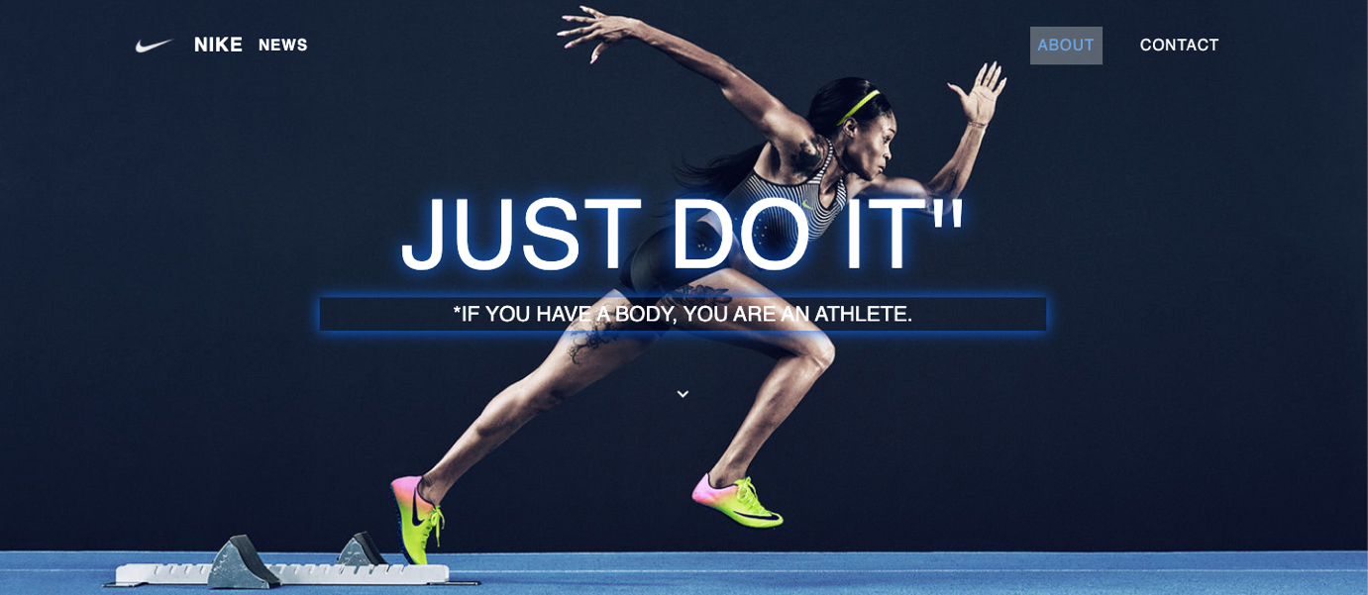

****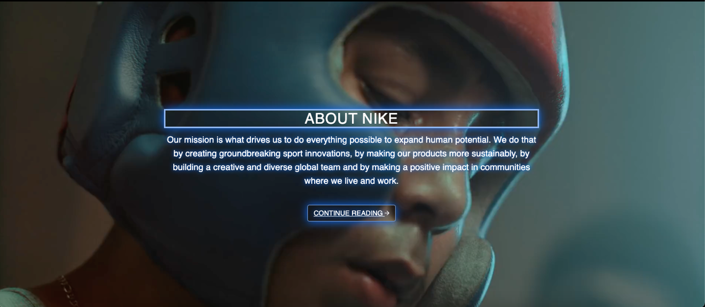

Page 1

Page 9

* **Mobile view of index page**

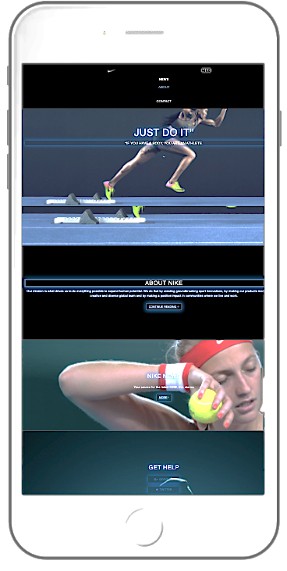

Page 10

* **Desktop view of About page:**

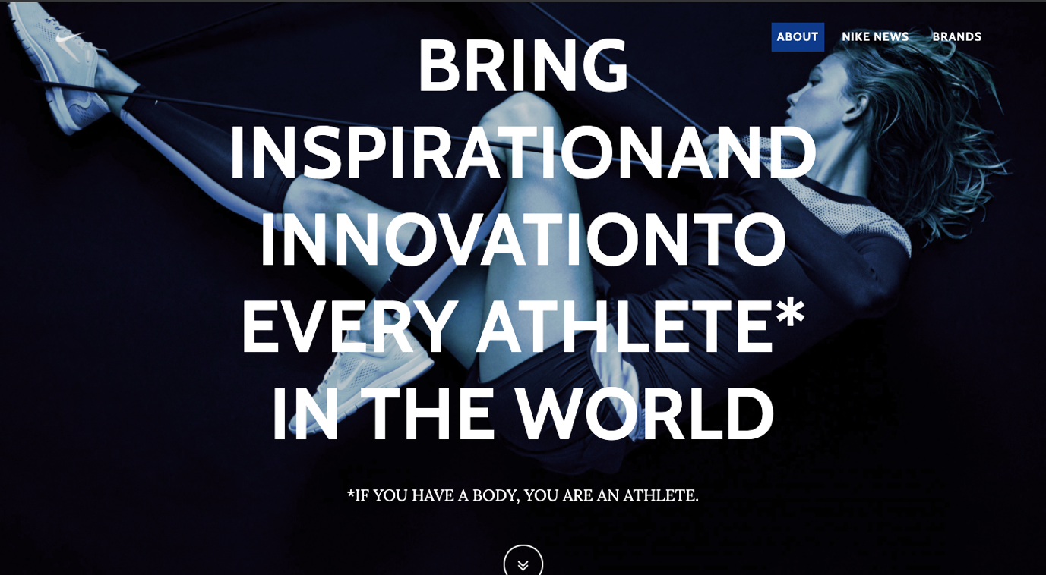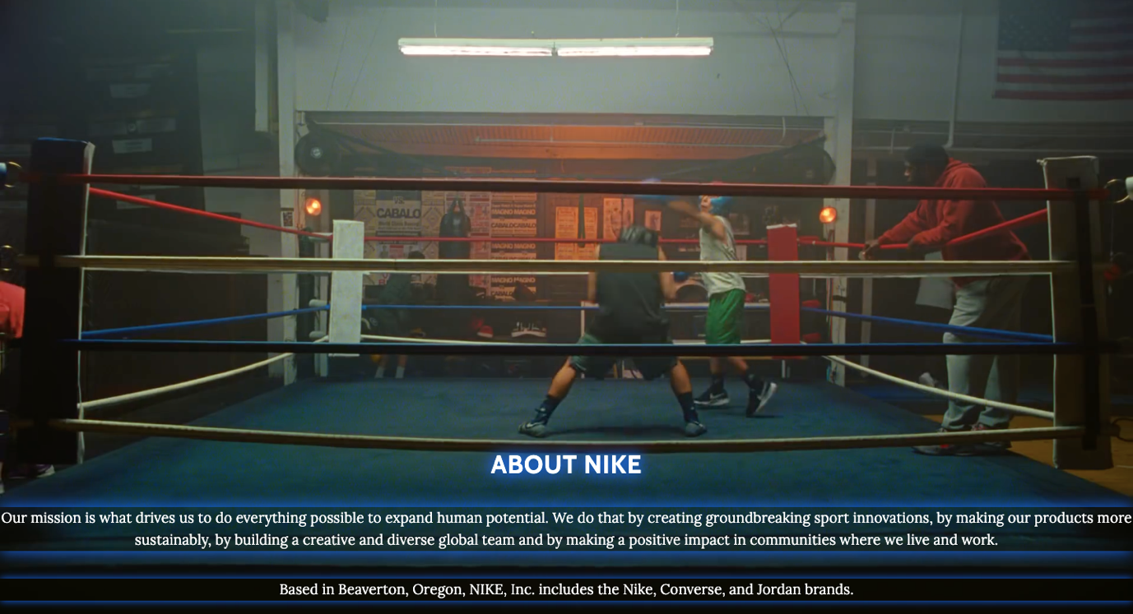

Page 11

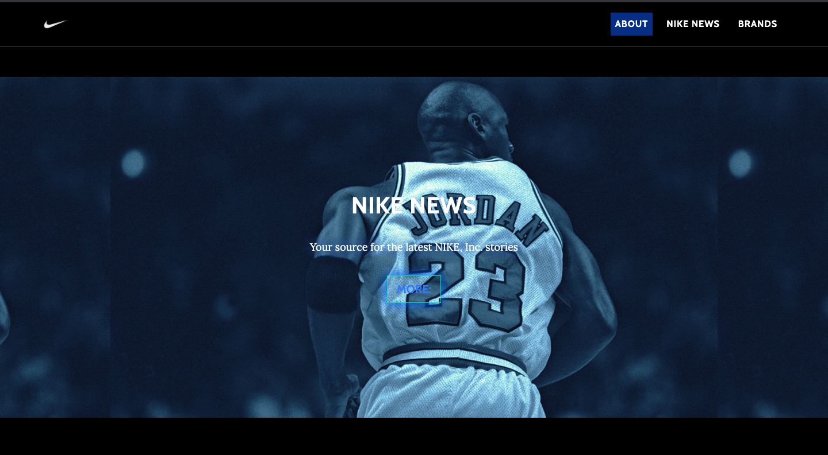

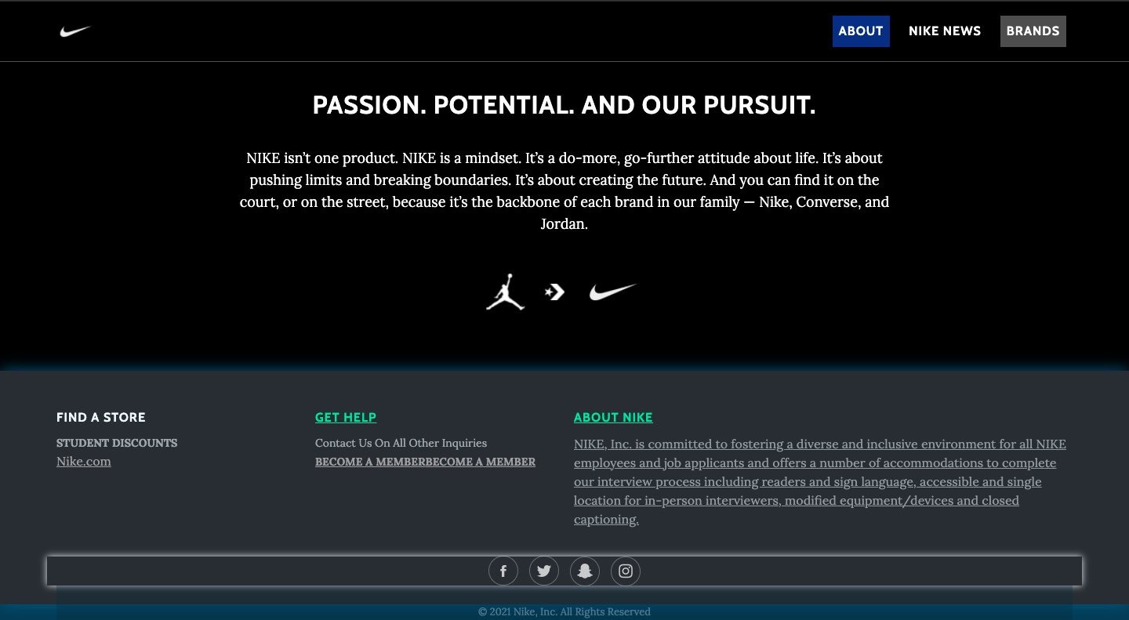

Page 12

* **mobile view of About page:**

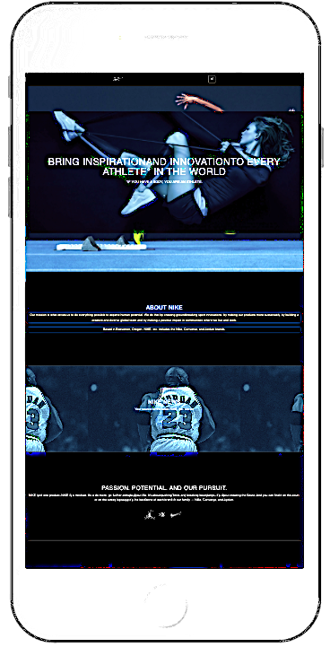

Page 13

* 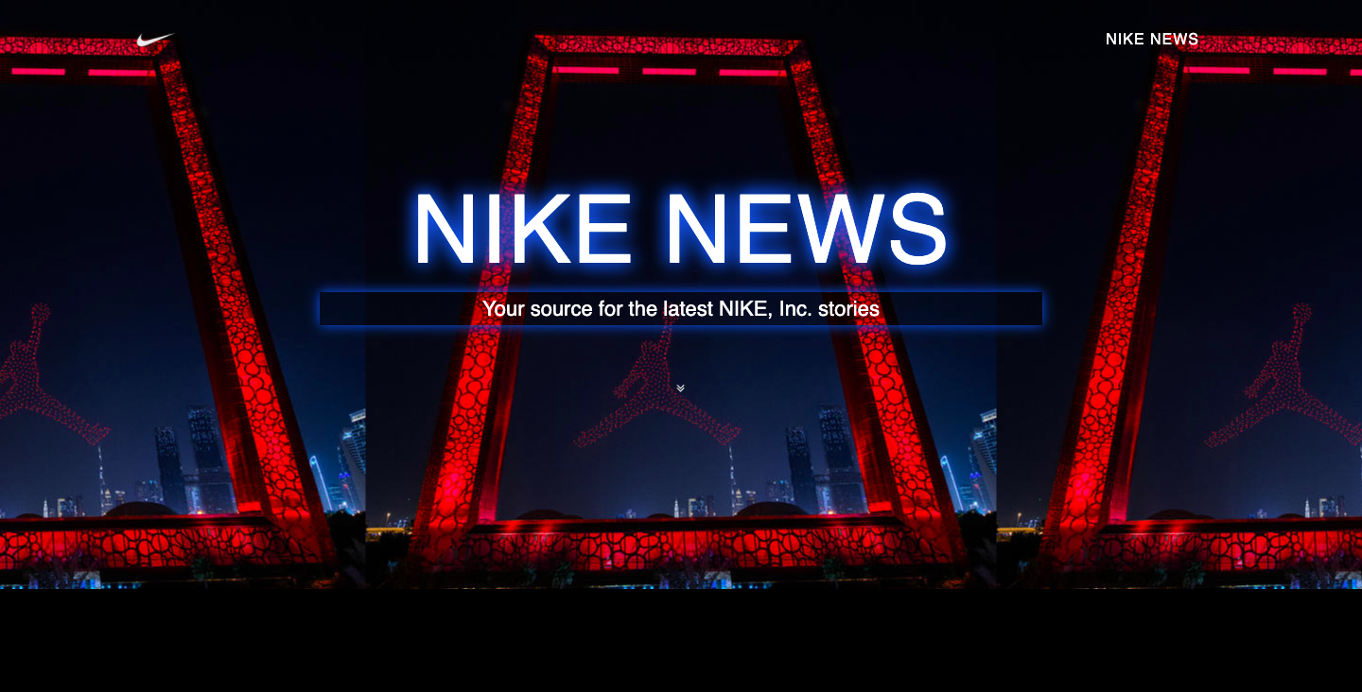**Desktop view of News page:**

Page 14

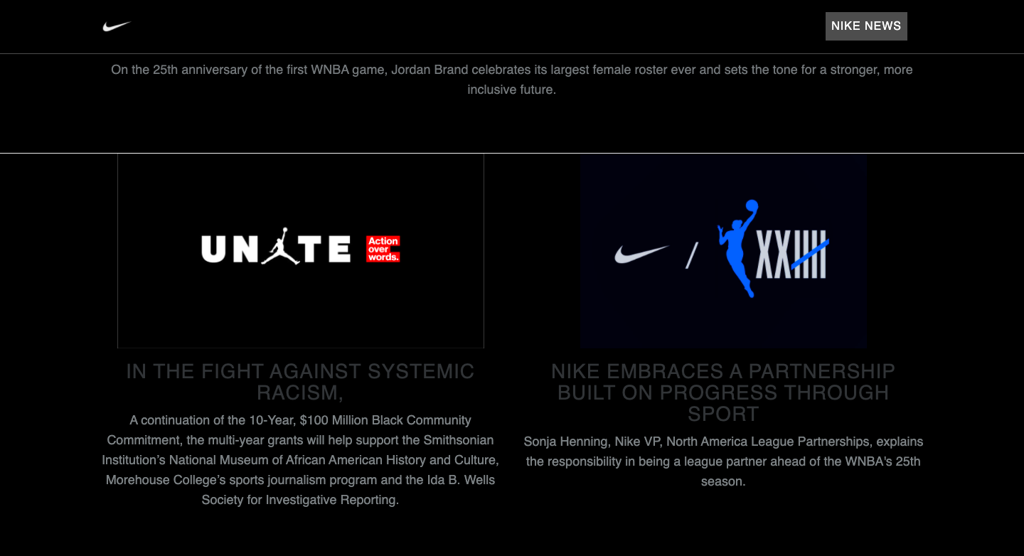

* 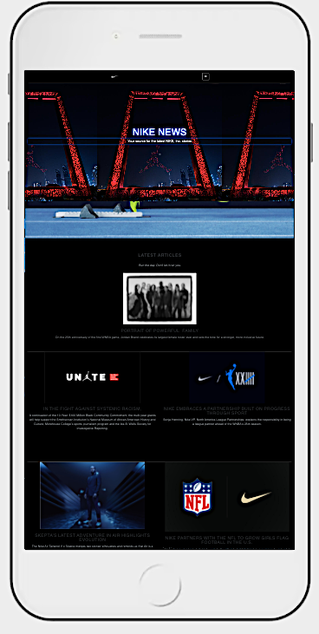**Mobile view of About page:**

Page 15

* **Desktop view of contact page:**



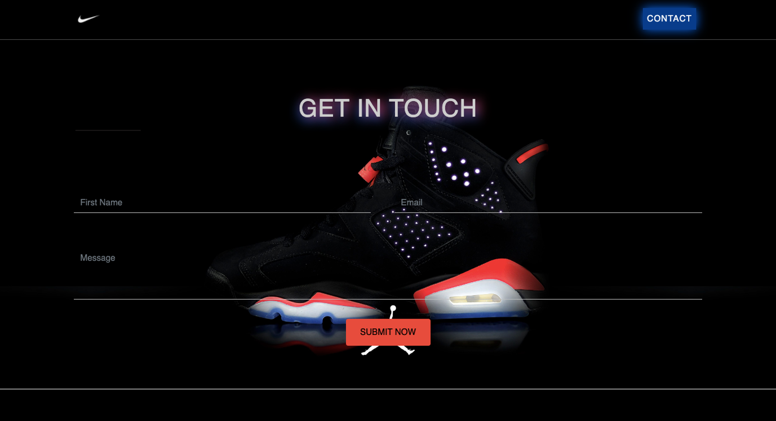

Page 16

Conclusion

There are many reasons building a website requires that we obtain the right tools and resources.

Standardization is one factor. When we use the right tools, we are assured that our pages would be standard and acceptable to every visitor.

By using standard resources and tools, our visitors are able to view our web pages no matter what browser they use. Our pages would load faster and we would also be able to maintain the pages we have created with ease.

Using the right resources for our web design jobs will make our websites contemporary. They can easily integrate into current technologies and software. Our users would derive added value from our websites and contribute to its growth.

The right resources also make it easy for surfers to use our site. The standard tools used for creating the website will ensure that things such as navigation, menus and layout conform to current practices with which every web user is familiar with.

Our pages become attractive if we use the right tools. They can display correctly in the browser and your visitors would be glad to visit again because you appealed to then.

Search engines would index your website if the pages conform to their rules. Standard tools like blogs will produce pages that understand how search engines index pages so you will have the added advantage of increase visibility o the web.

Web tools make your web design job easy. The WYSIWYG interface makes you work with icons and not raw code. Coding can take away a lot of time and produce fatal errors if you are not proficient. GUI interfaces take away all the incidences of errors and labor, and give you something manageable.

Speed of implementation comes with the right tools. You can create a website and launch it in an hour with the right resources. You save on time, effort and never miss important deadlines.

Now that you are equipped with the right knowledge you can go about your web design with the assurance that you are going to produce something appealing and acceptable to most browsers.